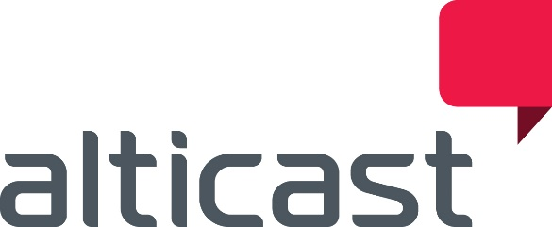

NAB 2019: Alticast Solutions Use ATSC 3.0 and Data Analytics to Deliver Personalized Media Experiences
FOR IMMEDIATE RELEASE
Broomfield, CO – March 26, 2019 – Alticast will highlight how it is using data to improve the overall user experience for content navigation, discovery and consumption from multiple sources (OTA, OTT and Pay TV) on various devices at its exhibit at NAB 2019 on April 8-11.
In its booth (South Upper Hall) SU10521CM, Alticast will showcase how it is transforming its solutions to help customers capitalize on the benefits and monetization opportunities of the ATSC 3.0 Next Gen Broadcast Standard. Alticast’s solution will demonstrate the ability to receive ATSC 3.0 content and deliver the content from a primary receiver to multiple companion devices seamlessly and efficiently in the digital connected home. The architecture of the solution is designed to support a dual-mode hybrid model for both ATSC 1.0 and 3.0, and diverse platforms like Android/Linux, etc.
Alticast will also have on display its data analytics platform, aidea™. This solution enables a real-time adaptive user experience, as well as personalized services, no matter where the content is coming from, or what device is being used to consume the content. A main feature of this solution will highlight an enhanced navigation experience that improves the search and discovery of relevant content for the viewers. It also supplies broadcasters and content providers with a dashboard for service usage and reporting, and implements an automated system operation for intelligent services based on real-time data.
“Today’s media consumer(s) want a tailored viewing experience that is personalized, adaptive and intuitive,” said Jae Park, President/GM, Alticast Americas. “Our technology allows broadcasters and content providers to offer a compelling and connected media experience that is designed to their viewers’ specific tastes, helping to open doors to new business models and monetization opportunities, especially as ATSC 3.0 ushers in a new era of immersive television.”
On Wednesday, April 10, Park will take part in a panel discussion “How can big data and analytics improve the TV experience?” at 12n in the Connected Media Debate Theatre in the South Upper Hall. The 45-minute session will highlight the opportunities and challenges that data analytics brings to the personalized TV experience and what broadcasters and operators need to know in order to realize the full potential that data analytics can bring to their services.
Those wishing to view the solutions or meet with the Alticast executive team during NAB2019 can contact mbaltz@alticast.com.

