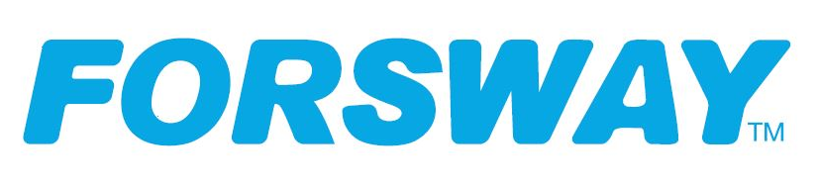

Press Release Gothenburg, 2021-07-19

KenCast and Forsway team up to provide robust multicast content delivery on cost-savvy satellite modem

Norwalk, Connecticut, and Gothenburg, Sweden, July 19th, 2021: Forsway, and KenCast today announced the two technology companies are partnering to deliver KenCast’s Fazzt multicast content delivery system on Forsway’s Odin F-50 satellite modem and cost-effective Forsway Xtend satellite platform.

A specialist in providing ultra-reliable content delivery over wireless and wired networks, KenCast can now offer a highly cost-savvy solution for underserved segments with poor connectivity by integrating its Fazzt multicast content solution with Forsway’s satellite broadband technology and hardware.

The Fazzt solution delivers flawless quality, even in the presence of extended outages, and enables significant savings on the satellite segment by reducing the need for retransmission. Accordingly, this partnership will provide customers best of breed hardware and software for multicast content delivery on a cost-effective platform to succeed in their markets.

- “While millions still have poor connectivity and infrastructure, the partnership will enable an expansion to provide underserved regions with a robust, low-cost and reliable connectivity, and Forsway to establish a footprint with new multicast capability,” says Tobias Forsell, CEO at Forsway.

- “Forsway will now also be able to offer its customer base its quality modem now further enhanced by KenCast multicasting capabilities used by Hollywood and the US government for their mission critical content requirements “

Sweden-based Forsway provides innovative solutions that combine satellite and existing terrestrial technologies to enable cost-efficient broadband services to regions lacking robust infrastructure and service, including service operators in Africa and Asia.

- “KenCast’s Fazzt content delivery system fundamentally complements Forsway’s satellite modem with an integrated terrestrial backlink,” says Dr. Henrik Axelsson, President, KenCast. By integrating the two solutions, together we can provide customers reliable, secure, and efficient multicasting of content on a cost-effective satellite platform. The combined product should open opportunities to new markets for both companies.”
KenCast is already trusted by major Hollywood movie studios, military and government agencies, major TV & news networks, retail, and financial institutions to provide fast, highly secure, and ultra-reliable global delivery of their most crucial multimedia content via wireless & wire terrestrial, satellite, and mobile networks.

- “KenCast often speaks with customers who ask if we can provide them and the hundreds (or thousands) of receive sites in their network a cost-effective hardware platform for our KenCast content delivery software,” continues Axelsson. “The KenCast-Forsway combined solution provides an excellent solution for these scenarios.’”

Current KenCast verticals include education (distance learning), media and entertainment, financial institutions, retail, military, and government agencies (including the US National Oceanic and Atmospheric Administration), digital signage, and more.

While today KenCast’s geographic core market is North and South America, the company believes the new integrated solution will attract strong interest in developing economies.

----
About Forsway Scandinavia AB

Forsway’s highly innovative hybrid hardware and technology combines satellite with existing terrestrial technologies enabling broadband services for the large demographics of users in underserved markets lacking reliable internet access. Forsway's unique solutions eliminate the need to deploy additional network infrastructure, creating significant time and cost savings for operators and service providers. The Forsway Xtend ecosystem is a complete toolkit and cost-effective hybrid satellite extension challenging the traditionally high cost of connecting hard-to-reach, underserved markets - rural areas in both emerging and established markets. Xtend is designed to remove the complexity of rolling-out satellite broadband to regions with limited infrastructure and monetize unused operator bandwidth. Learn more at www.forsway.com and follow us on LinkedIn, Twitter, Facebook and YouTube.

About KenCast
For nearly three decades, KenCast has been a market leader in content delivery. At the core of the solution are advanced algorithms that can repair for lost, degraded, or delayed multicast data, affordably enabling timely and reliable delivery of files and streams. KenCast powers marquee customers in multiple market segments, including entertainment and news networks, retail, finance, mobility and more, across 2,000 networks on every continent around the globe, offering a single system for both satellite and terrestrial networks to enable end-to-end control to any number of sites. The KenCast Fazzt system is a sophisticated and widely used tool to securely manage content while continuously optimizing efficiency via bandwidth management software, prioritization and performance monitoring tools, compression and encryption technology. Visit www.kencast.com to learn more.
Contacts

Forsway Scandinavia media contact
Leslie Johnsen
Communications Director
Mob: +47 41 45 80 43
Email: leslie.johnsen@forsway.com
Visit: www.forsway.com

